1.

**creating the table ‘titanic’ :**

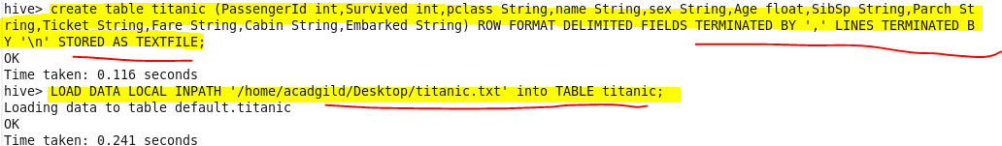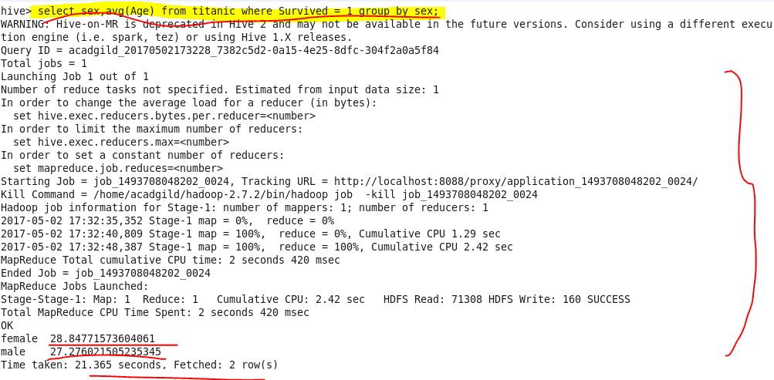

**2.**

**hive query to find the number of people died and survived in each class:**

